George Smith

Lab 6

First VidCast



Saul’s First Vidcast



Update a User

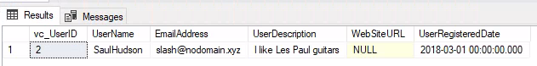

No more on time

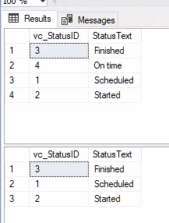

Tags

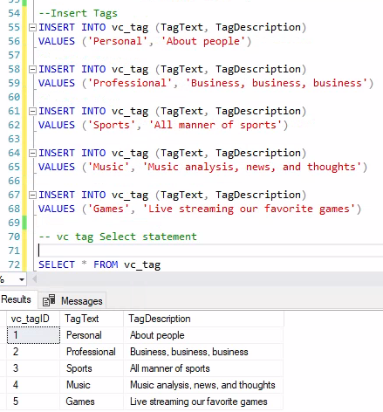

Users

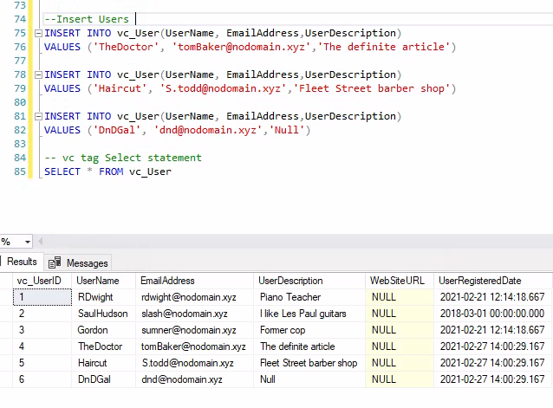

User Tag List

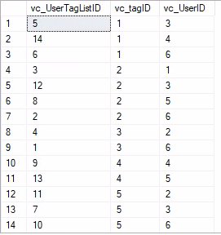

User Tags Report

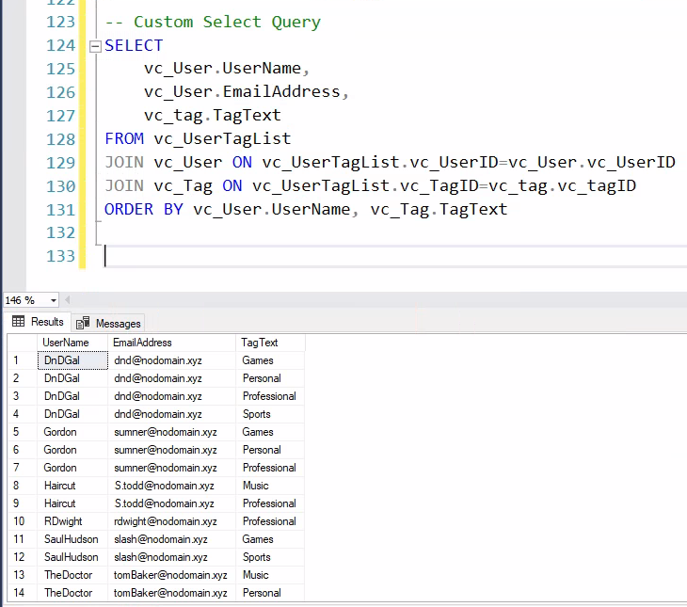

SQL Text

--Adding a two to the vc_Status table

INSERT INTO vc_Status (StatusText)

VALUES ('Scheduled')

-- The following line shows all of the rows in vc_Status

SELECT * FROM vc_Status

--Adding three more rows to the vc_Status table

INSERT INTO vc_Status (StatusText)

VALUES ('Started'), ('Finished'), ('On time')

-- The following line shows all of the rows in vc_Status

SELECT * FROM vc_Status

SELECT * FROM vc_User WHERE UserName = 'SaulHudson'

SELECT * FROM vc_Status WHERE StatusText = 'Finished'

--Adding a vidcast record to the Vidcast Table

INSERT INTO vc_VidCast

(VidCastTitle, StartDateTime, EndDateTime, ScheduledDurationMinutes, RecordingURL, vc_UserID, vc_StatusID)

VALUES

('December Snow', '3/1/2018 14:00', '3/1/2018 14:30', 30, '/XVF1234', 2,3)

--Read all rows from vc_VidCast

SELECT * FROM vc_VidCast

SELECT

vc_User.UserName,

vc_User.EmailAddress,

vc_VidCast.VidCastTitle,

vc_VidCast.StartDateTime,

vc_VidCast.EndDateTime,

vc_VidCast.ScheduledDurationMinutes / 60.0 as ScheduledHours,

vc_Status.StatusText

FROM vc_VidCast

JOIN vc_User on vc_VidCast.vc_UserID = vc_User.vc_UserID

JOIN vc_Status ON vc_VidCast.vc_statusID = vc_Status.vc_StatusID

WHERE vc_User.UserName = 'SaulHudson'

ORDER BY vc_VidCast.StartDateTime

--Correcting a User's USER RegisteredDate

UPDATE vc_User SET UserRegisteredDate = '3/1/2018' WHERE UserName = 'SaulHudson'

SELECT * FROM vc_User WHERE UserName = 'SaulHudson'

-- See what rows we have in status

SELECT * FROM vc_Status

-- Delete the On time status

DELETE vc_Status WHERE StatusText = 'On time'

--See the effect

SELECT * FROM vc_Status

--Insert Tags

INSERT INTO vc_tag (TagText, TagDescription)

VALUES ('Personal', 'About people')

INSERT INTO vc_tag (TagText, TagDescription)

VALUES ('Professional', 'Business, business, business')

INSERT INTO vc_tag (TagText, TagDescription)

VALUES ('Sports', 'All manner of sports')

INSERT INTO vc_tag (TagText, TagDescription)

VALUES ('Music', 'Music analysis, news, and thoughts')

INSERT INTO vc_tag (TagText, TagDescription)

VALUES ('Games', 'Live streaming our favorite games')

-- vc tag Select statement

SELECT * FROM vc_tag

--Insert Users

INSERT INTO vc_User(UserName, EmailAddress,UserDescription)

VALUES ('TheDoctor', 'tomBaker@nodomain.xyz','The definite article')

INSERT INTO vc_User(UserName, EmailAddress,UserDescription)

VALUES ('Haircut', 'S.todd@nodomain.xyz','Fleet Street barber shop')

INSERT INTO vc_User(UserName, EmailAddress,UserDescription)

VALUES ('DnDGal', 'dnd@nodomain.xyz','Null')

-- vc tag Select statement

SELECT * FROM vc_User

--Appendix B code

INSERT INTO vc_UserTagList (vc_UserID, vc_TagID)

VALUES

((SELECT vc_UserID FROM vc_User WHERE UserName='DnDGal'),

(SELECT vc_TagID FROM vc_Tag WHERE TagText='Sports')),

((SELECT vc_UserID FROM vc_User WHERE UserName='DnDGal'),

(SELECT vc_TagID FROM vc_Tag WHERE TagText='Professional')),

((SELECT vc_UserID FROM vc_User WHERE UserName='RDwight'),

(SELECT vc_TagID FROM vc_Tag WHERE TagText='Professional')),

((SELECT vc_UserID FROM vc_User WHERE UserName='SaulHudson'),

(SELECT vc_TagID FROM vc_Tag WHERE TagText='Sports')),

((SELECT vc_UserID FROM vc_User WHERE UserName='Gordon'),

(SELECT vc_TagID FROM vc_Tag WHERE TagText='Personal')),

((SELECT vc_UserID FROM vc_User WHERE UserName='DnDGal'),

(SELECT vc_TagID FROM vc_Tag WHERE TagText='Personal')),

((SELECT vc_UserID FROM vc_User WHERE UserName='Gordon'),

(SELECT vc_TagID FROM vc_Tag WHERE TagText='Games')),

((SELECT vc_UserID FROM vc_User WHERE UserName='HairCut'),

(SELECT vc_TagID FROM vc_Tag WHERE TagText='Professional')),

((SELECT vc_UserID FROM vc_User WHERE UserName='TheDoctor'),

(SELECT vc_TagID FROM vc_Tag WHERE TagText='Music')),

((SELECT vc_UserID FROM vc_User WHERE UserName='DnDGal'),

(SELECT vc_TagID FROM vc_Tag WHERE TagText='Games')),

((SELECT vc_UserID FROM vc_User WHERE UserName='SaulHudson'),

(SELECT vc_TagID FROM vc_Tag WHERE TagText='Games')),

((SELECT vc_UserID FROM vc_User WHERE UserName='Gordon'),

(SELECT vc_TagID FROM vc_Tag WHERE TagText='Professional')),

((SELECT vc_UserID FROM vc_User WHERE UserName='HairCut'),

(SELECT vc_TagID FROM vc_Tag WHERE TagText='Music')),

((SELECT vc_UserID FROM vc_User WHERE UserName='TheDoctor'),

(SELECT vc_TagID FROM vc_Tag WHERE TagText='Personal'))

--VC UserTagList recprds

SELECT * FROM vc_UserTagList

-- Custom Select Query

SELECT

vc_User.UserName,

vc_User.EmailAddress,

vc_tag.TagText

FROM vc_UserTagList

JOIN vc_User ON vc_UserTagList.vc_UserID=vc_User.vc_UserID

JOIN vc_Tag ON vc_UserTagList.vc_TagID=vc_tag.vc_tagID

ORDER BY vc_User.UserName, vc_Tag.TagText